**ONLINE VOTING SYSTEM UML DIAGRAMS**

**R.RITHVIK ROSHAN**

**192124021**

**1.USE CASE DIAGRAM**

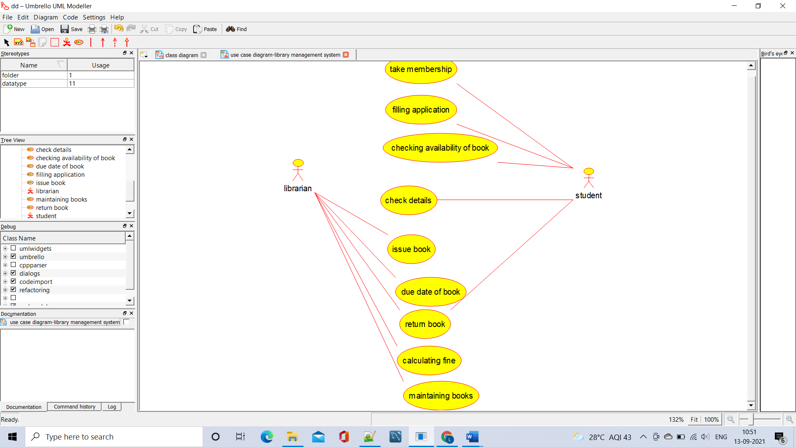

**2.SEQUENCE DIAGRAM**

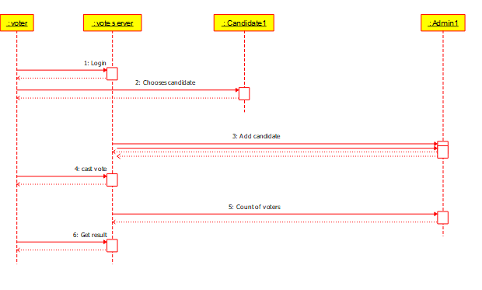

**3.CLASS DIAGRAM**

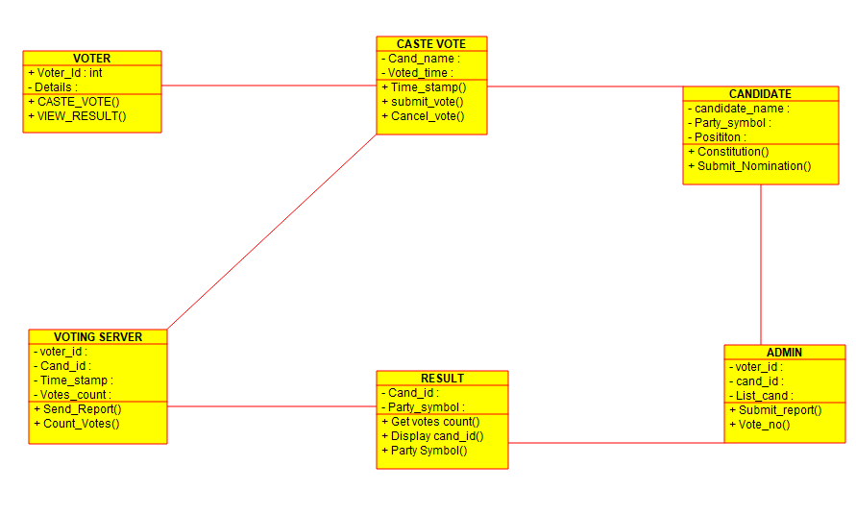

**4.ACTIVITY DIAGRAM**

